Reannen Brewer
Intro. To nanotechnology 4:00-5:15pm
Wesley Sanders
ENGR 1050 nanoscience/ nanotechnology review
Bio Nano-robots
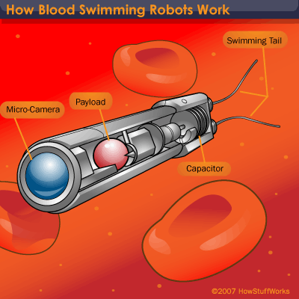
Nano-robots are tiny nanodevices that in the future will be used in maintaining and protecting the human body against diseases and viruses. The reason that I say in the future is because they have not been tested to a point where they can actually do human/animal trials yet. They are still very much in development. It is believed that when nano-robots become a reality that they will be very small having the diameter of about 0.5 to 3 microns. The parts that will be used to construct them will range from 1 to 100 nanometers. Nano-robots look rather dangerous and peculiar in that many conceptions of their design look like bacteria. They are a long cylindered tube that has a micro camera attached with a micro sized motor that motorized the swimming tail in the back that acts like bacteria’s flagella. It is perceived that hundreds of nano-robots will be injected into the bloodstream of a patient to monitor vital and even early detection and removal of cancer and tumor cells.
The reason that I selected this topic was that my major is going to be in the medical/ science field in Veterinary Medicine, and I am fascinated by nano-robots. Animals do not tell you when you are sick, they try to hide it and before you know it they could be majorly ill or even dead. The idea of a robot measuring life signs and health of a patient is incredible, since animals cannot actually say where their hurting, these nano robots will give a huge insight to the health of your animal. Plus I have always been interested in tiny robots, and helping with cancer patients.
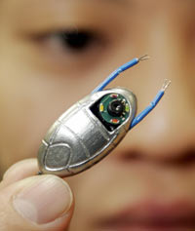
Today scientists are working diligently to create robots that would be able to work in the human body. So far they have been able to prototype and actually create a robot 2 centimeters long, this robot is in full working order but, in the future nano-robots will be a hundred times smaller. Another current advancement in the field of nano-robotics is using nano-robots to repair astronaut’s suits when they are on a mission to mars. When the first manned mission to mars sets forth the astronauts will engage in strenuous activity that will include; taking samples, hiking, climbing rocks and digging for sample. This activity will last from 18 to 20 months and the wear and tear on the suits will be extraneous, that is why the idea of using nano-robots to repair these suits is being tested, because the health of the astronaut all depends on the durability of his suit. They are already testing applications of these tiny robots in many different environments.
A fundamental science that relates to nano-robotics is biology, because nanorobots will have a big impact on the medical field. They will be used in hospitals, doctor’s offices, and in laboratories. They will be injected into human bodies where they will remove blood clots, and detect cancer and tumor cells.
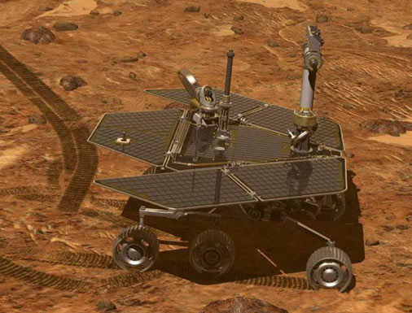
Two very useful applications of nano-robots are one; they can be injected in to the blood stream of patients to detect a number of things. They will have biosensors that will monitor the vitals of the patient and inform of any odd occurrences and life threatening diseases. They will also be able to detect blood clots and will remove them in a single or team effort. They will also be able to detect forming cancer and tumor cells and will be able to hinder the growth of the cells and saving lives. The second is to use nano-robots to repair things in space. They can be used to repair space suits worn by astronauts during long and strenuous missions in space, where the structural integrity of the suit would be compromised. This is most important on the future missions to Mars where the astronauts will most likely spend 18 to 20 months on the surface with haranguing conditions. They will also be used in other manned missions to different planets in our Solar system and beyond. These are just one of the many applications of these amazing robots.

